Sunday | Monday | Tuesday | Wednesday |  | Thursday | Friday | Saturday
 |  |  |  | 1 | 2 | 3 | 4
5 | 6  Purim Begins | 7 |  | 8 | 9 | 10 | 11
12  Daylight Saving Time Begins | 13 | 14 |  | 15 | 16 | 17  St. Patrick’s Day | 18
19 | 20  Spring Begins | 21 |  | 22  Ramadan Begins | 23 | 24 | 25
26 | 27 | 28 |  | 29 | 30 | 31

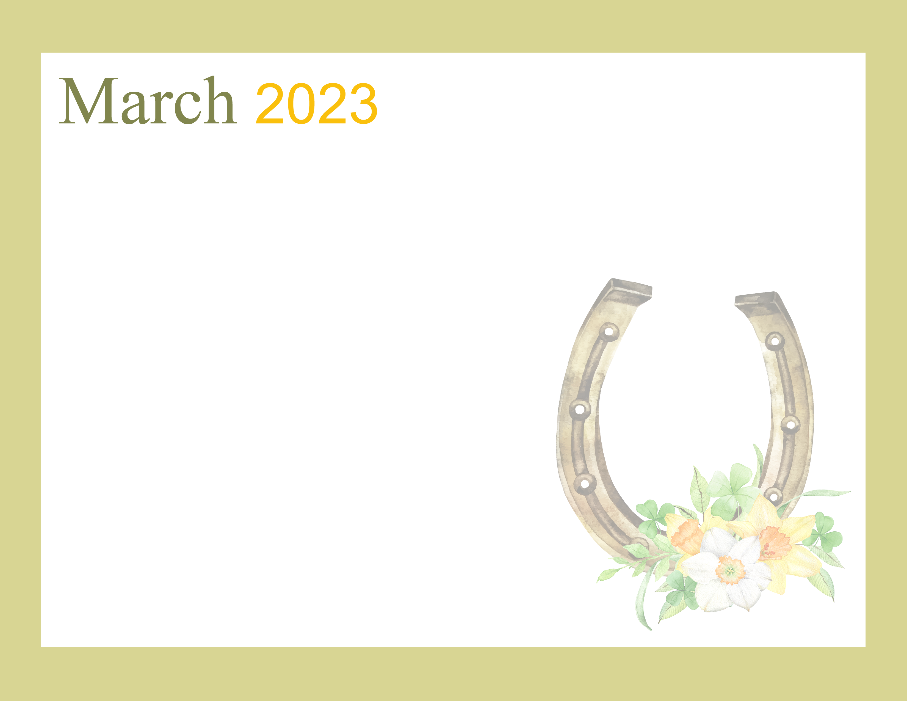  Retirement Center |  |  | 10:00 Coffee Hour  11:30 Episcopal  Communion  3:30 Bible Study w/Chaplain Jim in Nursing Center | 3:00 Bible Study | 10:00 Shopping  10:30 Rosary & Hymns  2:00 Music with Chris Waters | 2:00 Bingo with Pat
10:30 Hymns in the Chapel | 10:00 Matter of Balance Class | 10:00 Walmart  2:00 Donna’s Dancers | 10:00 Coffee Hour  2:00 Bingo!  3:30 Bible Study w/Chaplain Jim in Nursing Center | 11:00 Lunch at Olive Garden  2:00 Music with Tony & Pat  3:00 Bible Study | 10:00 Shopping  10:30 Rosary & Hymns  2:00 Blood Pressure Checks  Soup Sale
10:30 Hymns in the Chapel | 10:00 Matter of Balance Class  3:30 Vespers | 10:00 Dave’s Market  2:00 Music with the Hibernians | 10:00 Coffee Hour  11:30 Legacy Giving Seminar and Lunch  2:00 Bingo!  3:30 Bible Study w/Chaplain Jim in Nursing Center | 11:00 Catholic Mass  1:30 Tenant Meeting  2:00 Music with Dave Manuel  3:00 Bible Study | 10:00 Shopping  10:30 Rosary & Hymns   | 2:00 Bingo with Pat
10:30 Hymns in the Chapel | 10:00 Matter  of Balance Class   | 2:00 Bingo! | 10:00 Coffee Hour  3:30 Bible Study w/Chaplain Jim in Nursing Center | 2:00 Garden Club Meeting  3:00 Bible Study  6:00 Movie Night | 10:00 Shopping  10:30 Rosary & Hymns  Soup Sale
10:30 Hymns in the Chapel | 10:00 Matter of Balance Class  3:30 Vespers | 9:00 Breakfast at IHOP  2:00 Bowling | 10:00 Coffee Hour  2:00 Bingo!  3:30 Bible Study w/Chaplain Jim in Nursing Center | 3:00 Bible Study | 10:00 Shopping  10:30 Rosary & Hymns  2:00 Music with Bobby B
.

